MiSACWIS Project

CF16 – Find an Employee UCR

Version 0.3

January 03, 2012

Prepared for:


120 N. Washington Square
SACWIS Project, 3rd Floor
Lansing, MI 48933

Prepared by:

Revision Log
Version | Date | A/D/C (Add, Delete, Change) | Author | Document Section # | Description
0.1 | 07/18/2011 |  | Matthew McElver |  | Initial version
0.2 | 12/12/2011 | A | S Kulkarni | 4 | CRUD Matrix
0.3 | 01/03/2012 | A | S Kulkarni | 2 | Class diagram

Table of Contents
1 Introduction 5
1.1 Purpose 5
1.2 Scope 5
2 Class Diagram 6
3 Sequence Diagrams 7
4 Business Data Dictionary 8
4.1 CRUD Matrix 8

List of Figures
Figure 1 – Class diagram 6

Introduction

Purpose
The CF16 - Find an Employee use case describes the process of finding an Employee in the MiSACWIS application. The employee search is primarily accessed from the Search hyperlink in the Header of the MiSACWIS application and then clicking on the Employee tab. This is commonly called the employee general search. Another use for the employee search would be as part of a specific workflow. For example the setting up of delegates (CF34 - Assign Delegate) requires the user find an employee. This use of the CF16 - Find an Employee is called a sub-function search. If used during a sub-function, this use case allows a user to add a new employee by clicking on the Add Employee button.

Scope
A user can search for an employee using a combination of multiple search criteria. For example, employees can be found by typing in their name, the Employee ID, the Organization, District, Section, Unit or Job Title. To help narrow the search a user can also search by Licenses, Training Skills, Language Proficiency, Assignment Roles and if the employee is a current employee or a supervisor.

Class Diagram
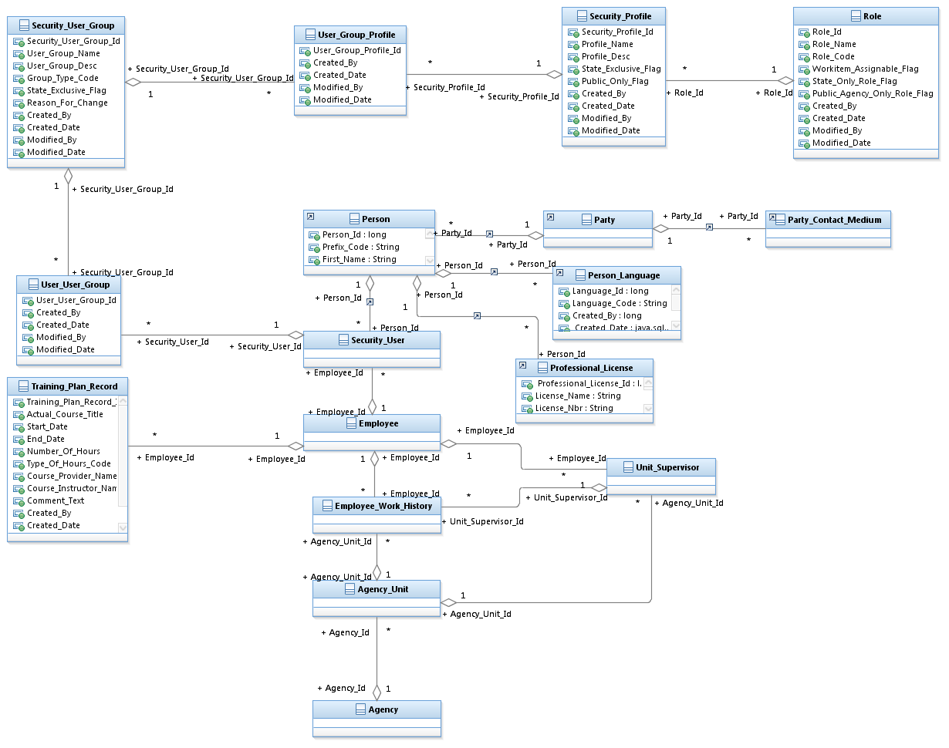
Figure 1 – Class diagram

- Sequence Diagrams

- Business Data Dictionary
  - CRUD Matrix

Class | Create | Read | Update | Delete
Agency |  | X | X
Agency_Unit |  | X | X
Employee |  | X | X
Employee_Work_History |  | X | X
Person | X | X | X
Person_Language |  | X
Party |  | X | X
Party_Contact_Medium |  | X | X
Professional_License |  | X
Role |  | X | X
Security_Profile |  | X
Security_User |  |  |  | X
Security_User_Group |  | X
Training_Plan_Record |  | X | X | X
Unit_Supervisor |  | X | X
User_Group_Profile
User_User_Group |  | X

